**PRACTICAL NO :05**

Aim :Implement a Stack and perform the stack operations: Push, Pop and Print using Menu Driver Program such as 1.Push, 2.Pop and 3. Print and 4.

Exit.

Program:

#include <iostream>

using namespace std;

int stack[100];

int top = -1;

void push(int value)

{

    if (top == 99)

     {

        cout << "Stack Overflow\n";

    }

    else

    {

        top++;

        stack[top] = value;

        cout << value << " pushed into stack\n";

    }

}

void pop()

{

    if (top == -1)

     {

        cout << "Stack Underflow\n";

    }

     else

      {

        cout << stack[top] << " popped from stack\n";

        top--;

    }

}

int main()

 {

    int choice, value, n;

    cout << "Enter number of elements you want to push: ";

    cin >> n;

    for (int i = 0; i < n; i++)

    {

        cout << "Enter value" << (i + 1) << ": ";

        cin >> value;

        push(value);

    }

    while (true)

     {

        cout << "\n1. Push\n2. Pop\n3. Exit\nEnter your choice";

        cin >> choice;

        if (choice == 1)

        {

            cout << "Enter value to push: ";

            cin >> value;

            push(value);

        } else if (choice == 2) {

            pop();

        } else if (choice == 3) {

            cout << "Exiting...\n";

            break;

        } else {

            cout << "Invalid choice, try again.\n";

        }

    }

    return 0;

}

Output:

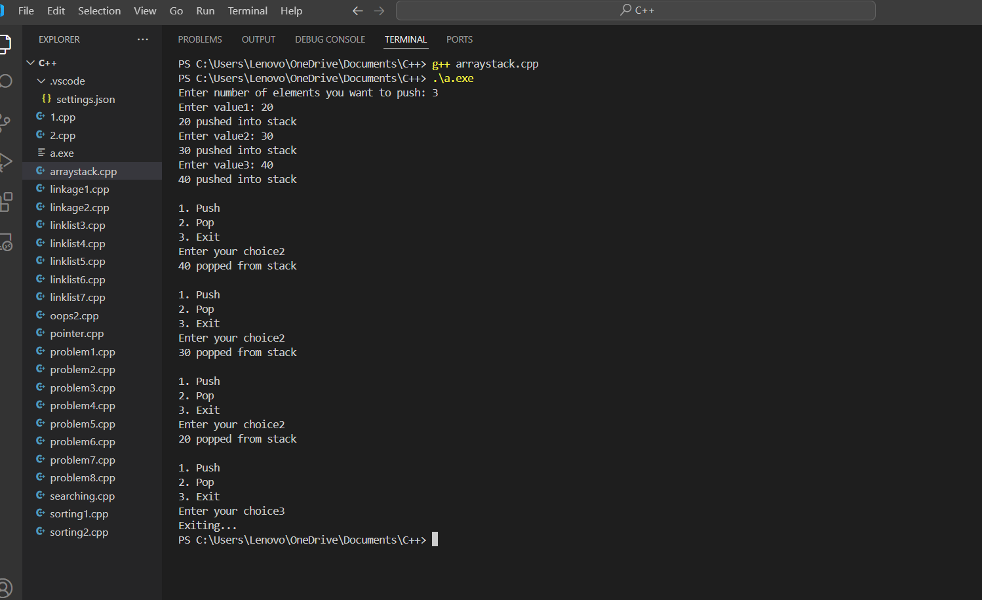

B] Using Linklist :-

#include <stdio.h>

#include <stdlib.h>

struct Node {

int data; struct Node* next;

};

struct Node* top = NULL;

void menu() {

printf("1.PUSH\n2.POP\n3.PRINT\n4.EXIT\n");

}

void PUSH() {

struct Node* newNode = (struct Node*)malloc(sizeof(struct Node)); if (!newNode) {

printf("Stack Overflow\n");

return;

}

printf("Enter value to push: "); scanf("%d", &newNode->data); newNode->next = top; top = newNode;

}

void POP() { if (top == NULL) { printf("Stack Underflow\n"); return;

}

struct Node* temp = top; printf("Pop element: %d\n", top->data); top = top->next; free(temp);

}

void PRINT() { if (top == NULL) { printf("No Element in Stack\n");

return;

}

struct Node* temp = top; printf("Elements in stack are:\n"); while (temp != NULL) { printf("%d \n", temp->data); temp = temp->next;

}

}

int main() { char ch; do { menu(); int choice; printf("Enter choice: "); scanf("%d", &choice);

switch (choice) { case 1: PUSH(); break; case 2: POP(); break; case 3: PRINT(); break; case 4: return 0; default:

printf("Invalid Choice\n"); break;

}

printf("\nDo you want to continue(Y/N): "); scanf(" %c", &ch); } while (ch == 'y' || ch == 'Y'); return 0;

}

Output:-

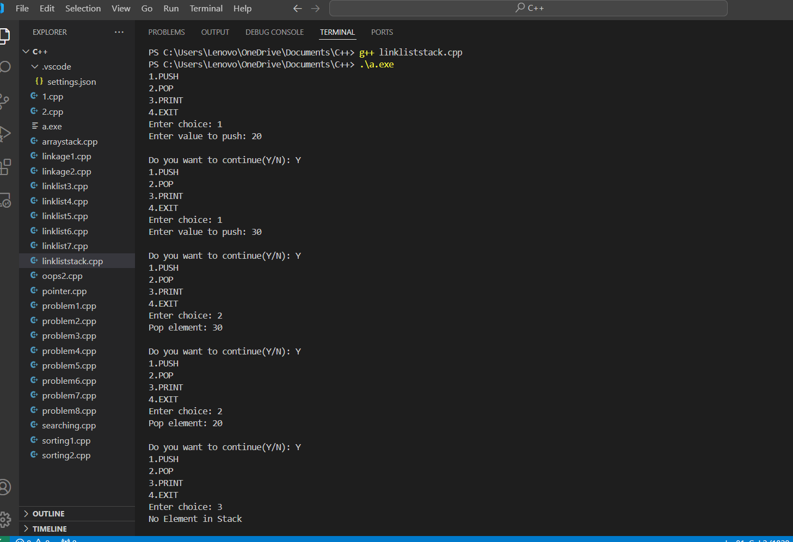

Github link : <https://github.com/Manas1597/DSA>